Q1

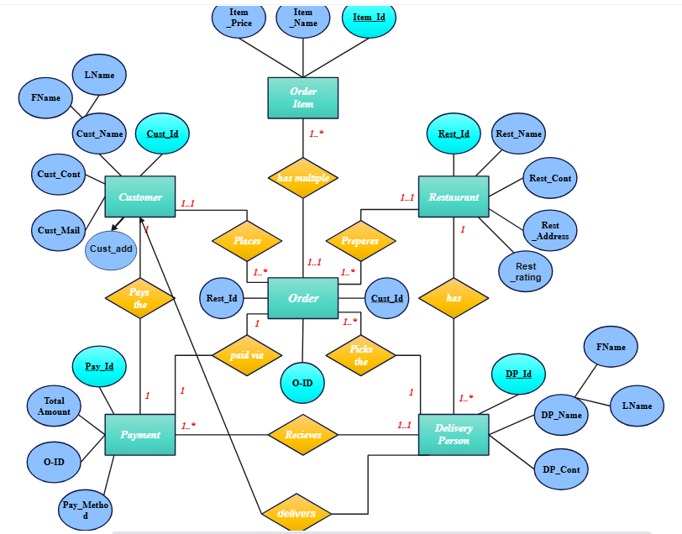

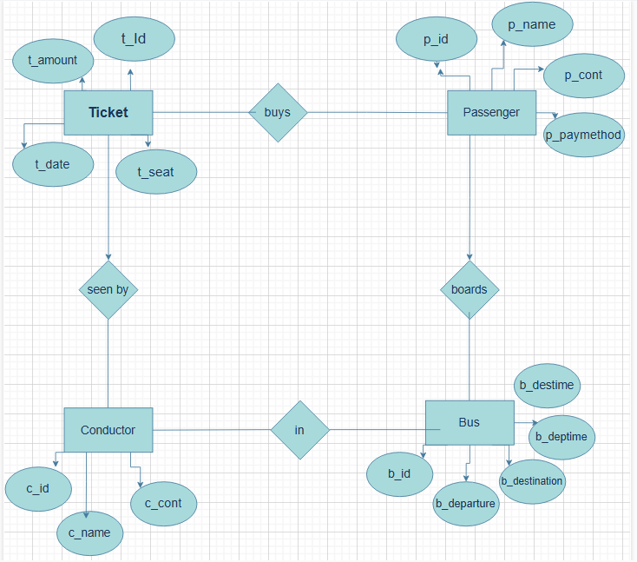

ER DIAGRAMS

Q2 A

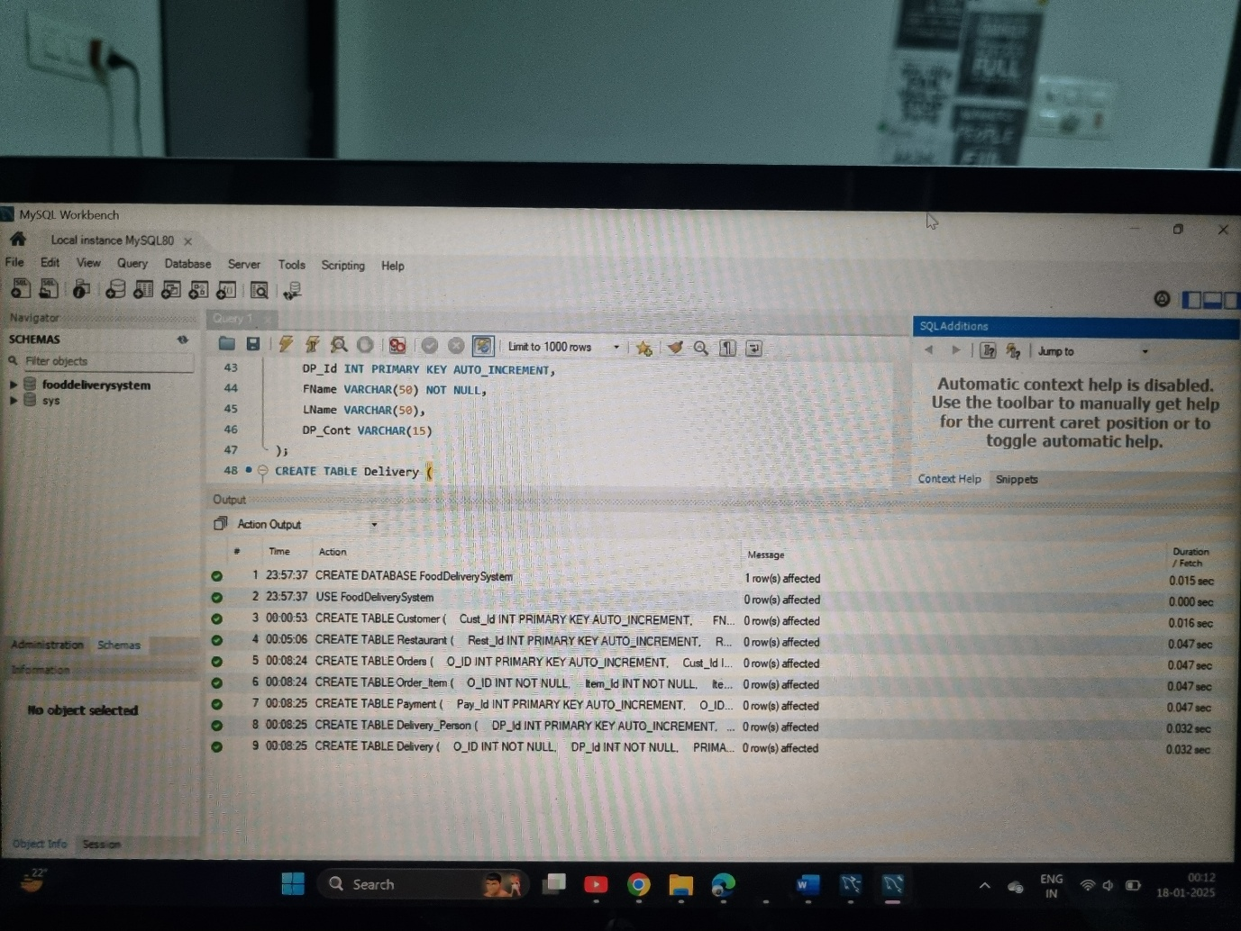

**INSERTED TABLES**

B

Sql file

C **3rd Normal Form (3NF)** was used to reduce redundancy and maintain data integrity. Tables like restaurants, menu, customers, orders, and order_items ensure clear separation of concerns and relationships.

Left normalized to maintain consistency. Denormalization can be considered for frequently accessed data.

**Storing Phone Numbers as Strings:**

**Benefits:**

1. Retains leading zeros and country codes (e.g., +91).
2. Supports special characters like + and - for formatting.
3. Handles diverse international formats.
4. Avoids unnecessary mathematical operations.

**Drawbacks:**

1. Requires more storage than integers.
2. Validation is more complex.
3. Slower indexing and query performance.  
   I stored Phone numbers as VARCHAR(15) to support international formats and preserve integrity, prioritizing flexibility over minimal storage.

Q3 a)

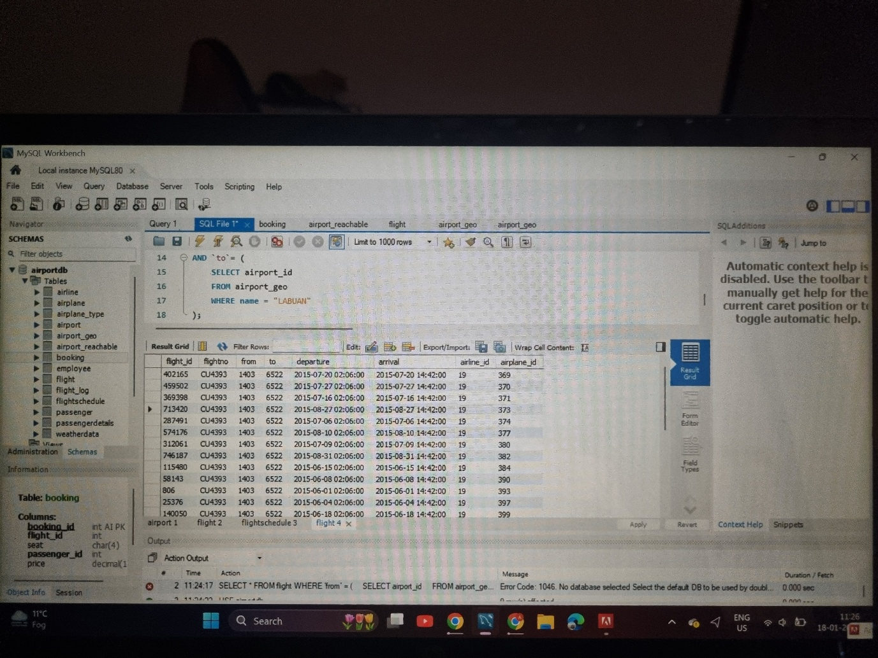

b)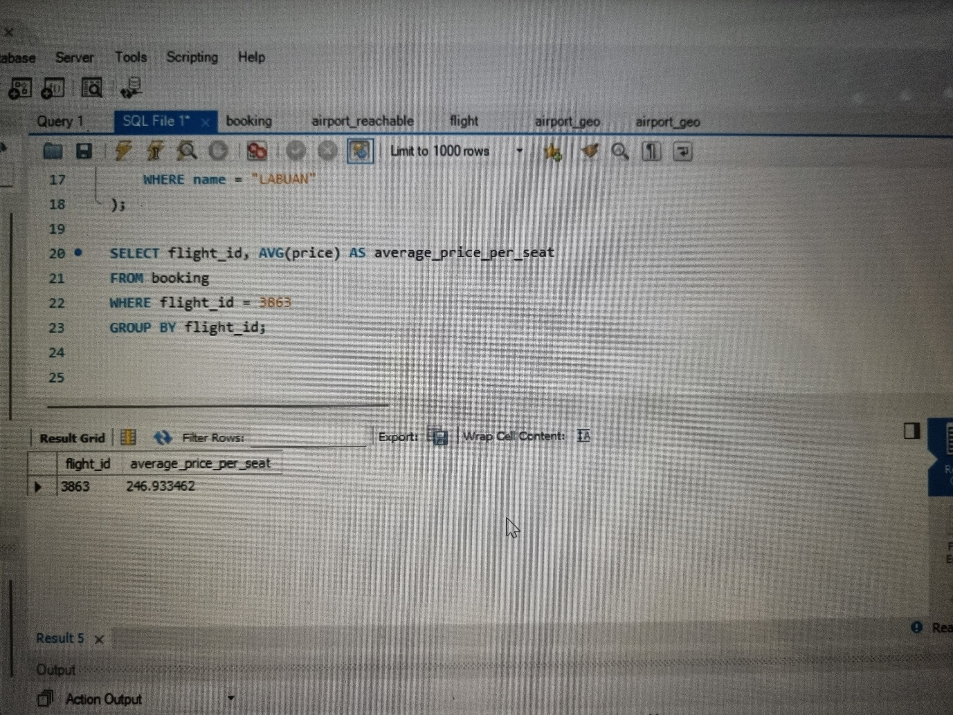

c) 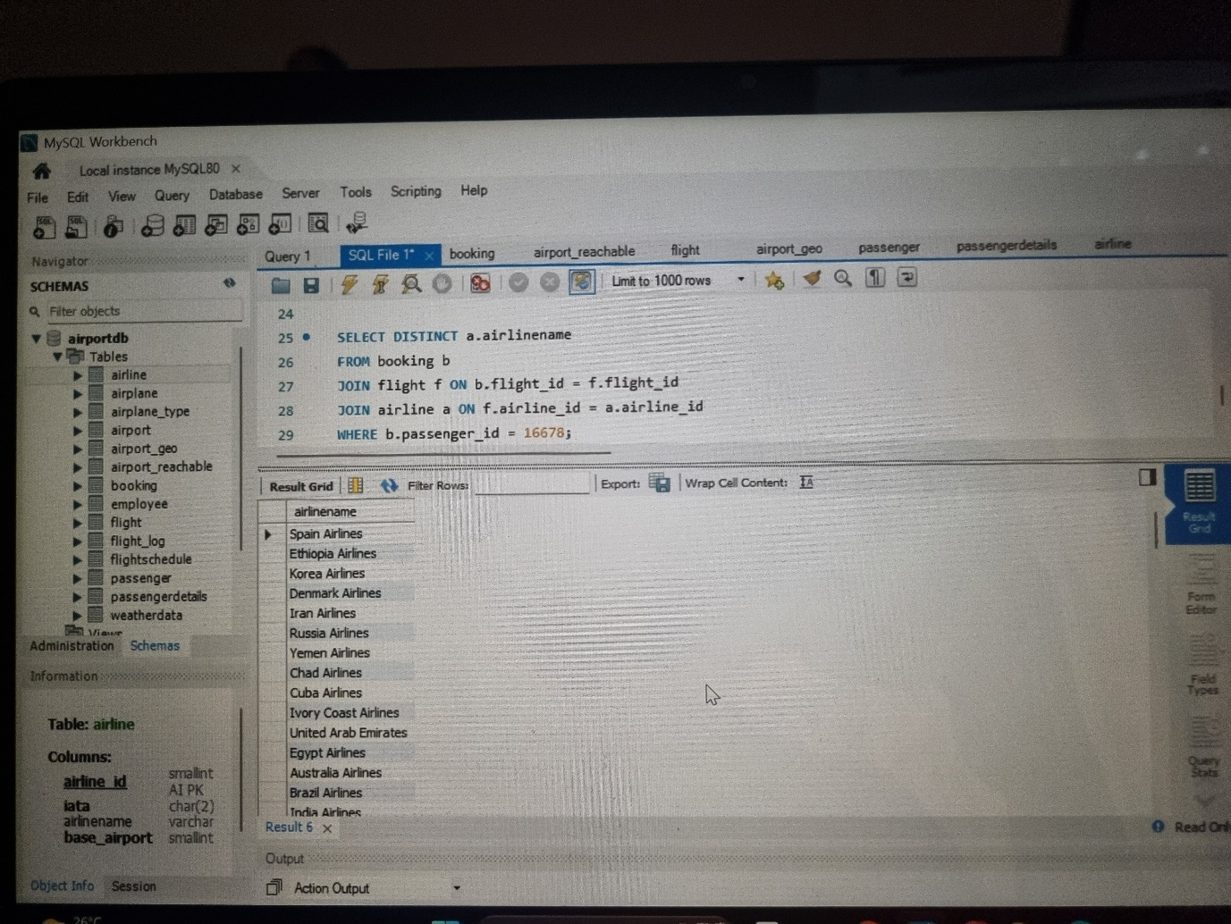

d)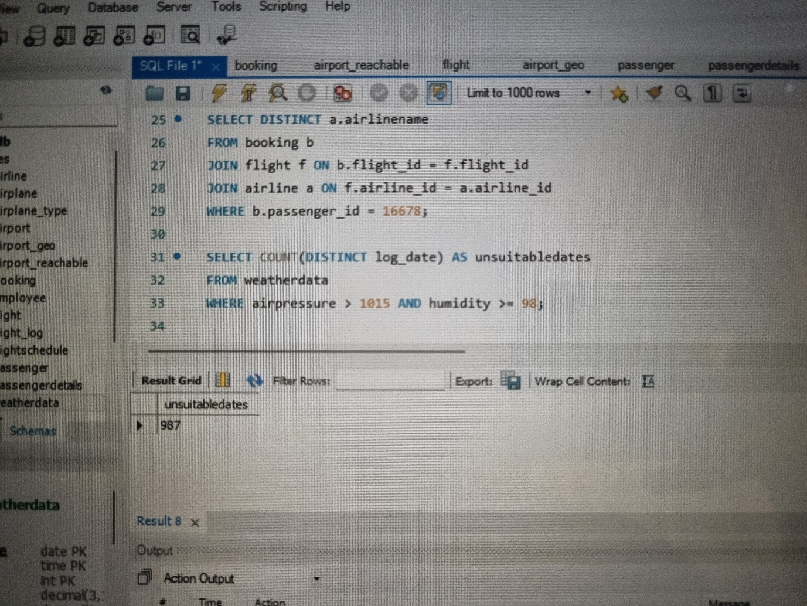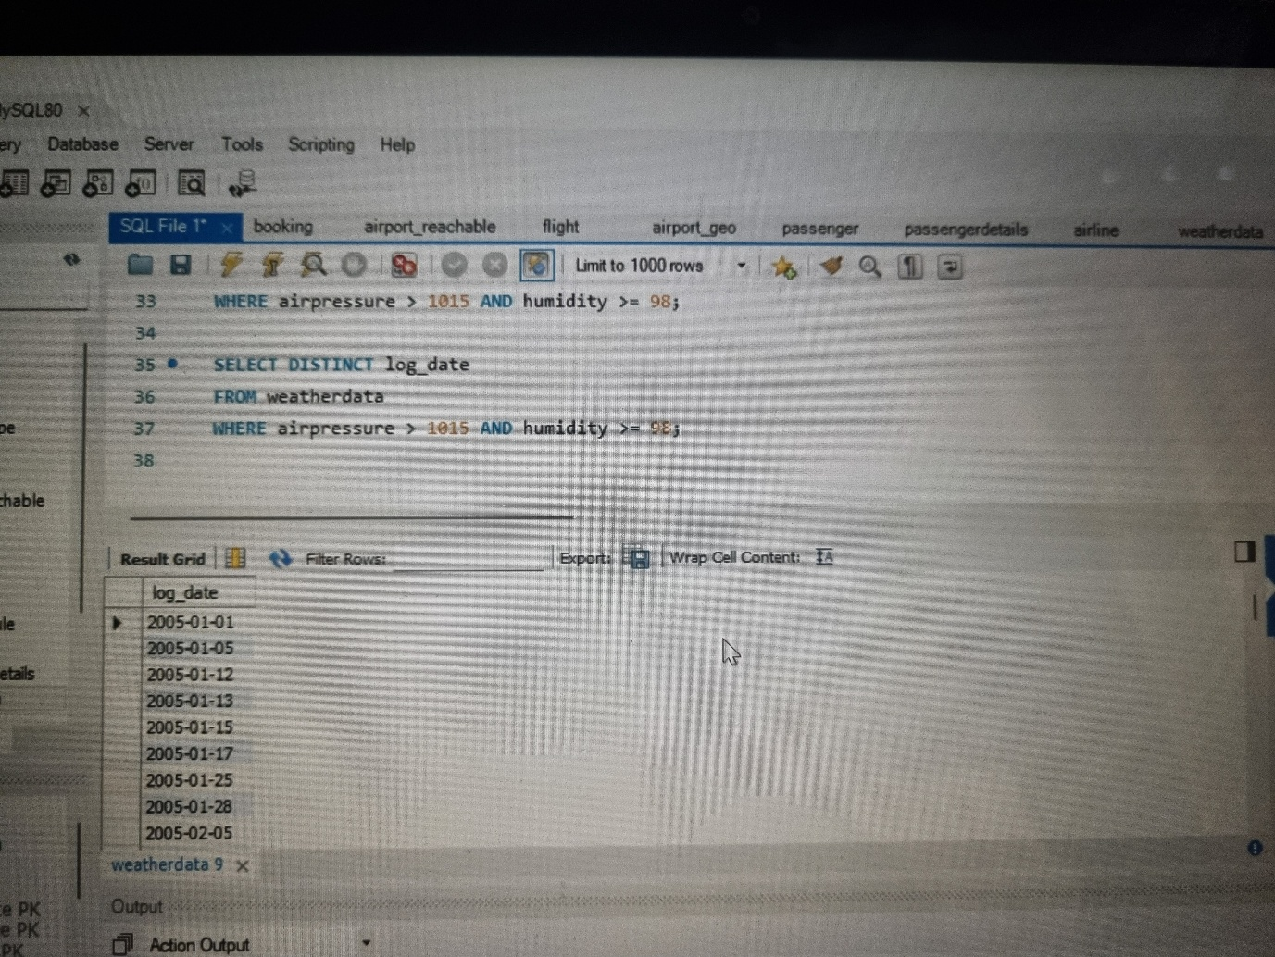

e)

